 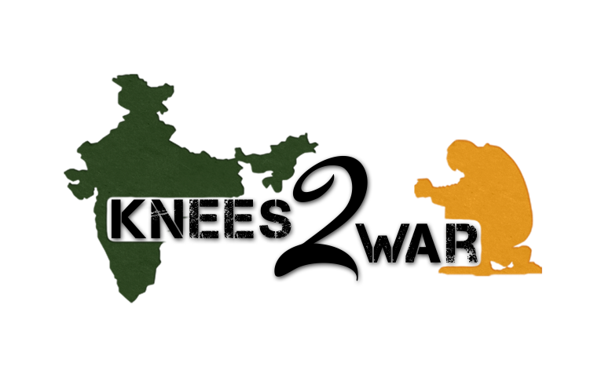

Touch India Ministries presents…

Knees 2 War

Tonkawa, OK

April 12, 2014

5K & 1mile run/walk

Proceeds support Children in India

**DATE/ TIME/ PLACE**: **Saturday, April 12th, 2014- 9:00am in downtown Tonkawa, OK, close to the Heart in the Park.**

The 1 mile run/walk begins at 9:00am, and the 5K run/walk begins at 9:30am. Race start/finish line location: Intersection of 7th St. and Grand

**COURSE DESCRIPTION/ Timing:** Out and back course. Manual timing.

**REGISTRATION/ FEES/PACKET PICK UP:** Participants are encouraged to pre-register either on-line at www.getmeregistered.com/Knees2War or by U.S. mail to: Knees 2 War, Attn: Linda Kodesh, 1111 S. Oakwood Rd, Apt. 1506, Enid, OK 73703. All mailed pre-registration forms must be post marked no later than the Saturday, April 5th. Online registration will be open through the Thursday, April 10th.

**1 mile-$20 5K-$25 Children 12 & under- $10 for any event *(add $5 for registrations on race day)***

Packet pick-up and late registration will be on the morning of the race from 7:30am – 8:30am at the location site.

**T-SHIRTS:** Pre-registered runners/walkers will receive t-shirts at packet pick-up. Race day registrants will receive shirts as supplies last.

**AWARDS:** An awards ceremony will follow the races. 5K- Awards will be given to top overall male and female and three deep in the following age divisions—male and female: 12 and under, 13-19, 20-29, 30-39, 40-49, 50-59, 60-69, 70+. Overall winners are not eligible for age division awards. 1 mile- Awards will be given to top three finishers. Awards MUST be picked up; they will NOT be mailed.

**POST RACE CELEBRATION:** Refreshments and water will be available for race participants.

**INFORMATION:** Contact race coordinators, Linda Kodesh- 580.716.0662 linda.knees2war@gmail.com

or Christi Hook- 580.716.2446 christi.hook@north-ok.edu

**RACE ETIQUETTE:** We reserve the right to disqualify anyone who displays unsportsmanlike conduct.

**Name: Last_______________________________ Address: ________________________________________**

**First______________________________ City: ____________________ ST _____ Zip ____________**

**Gender: (circle one) Male Female Phone: (______) _______ - ____________**

**Age: (as of 04/12/14) _______________ E-Mail Address: ________________________________________**

**Date of birth: Month____Day____Yr______**

**T-Shirt Size: 3T 5T YS YM YL S M L XL XXL**

**Race: (circle one) 5K 1 mile**

**In case of Emergency, call: ____________________________ at phone number: ___________________________**

**Athlete’s Release and Waiver: DO NOT SIGN WITHOUT READING**

**Complete and Mail to:**

I understand the nature of the activity of running/volunteering in a 5K/1 mile race. I certify that I am in good health and in proper physical condition to participate in this activity. I agree to abide by any decision of a race official relative to my ability to safely complete the run. I fully accept and assume all such risks and all responsibility for losses, costs, and damages I incur as a result of my participation in the activity. This includes but is not limited to falls, contact with other participants, and effects of weather including cold temperatures, humidity, rain, and the condition of the road or traffic on the course. All such risks are known and understood by me. I have read this release and waiver of liability. I understand these terms and understand that I have given up substantial rights by signing this agreement and have signed it freely. I hereby release, discharge, and promise not to sue Touch India Ministries, race administrators, race sponsors, and all further sponsors, their representatives, or successors from all claims or liability of any kind arising from my participation in this event even if the liability may arise out of negligence or carelessness on the part of the persons named in this waiver. I also grant permission to all the above groups to use any photograph, motion pictures, video, recordings, or any other record of this event for any legitimate purpose.

Knees 2 War/ Registration

Attn: Linda Kodesh

1111 S. Oakwood Rd, Apt. 1506

Enid, OK 73703

**Make Checks Payable to:**

Touch India Ministries

**OR**

**Visit www.knees2war.org or scan**

**code to register or donate online:**



_______________________________________________________________________

Athlete’s Signature Date

(or Parent/Guardian of participants under 18)